WEB BASED REMOTE CONSOLE: ITB11P04
INSTRUCTIONS TO RUN THE PROJECT

(First 2 instructions can be skipped if you have an Ubuntu operating system installed)

- Ensure that you have installed Ubuntu with the GNOME Desktop Environment (32 bit version is preferred for offline installation, as the bundled software is 32-bit).
- If you have not installed the operating system yet, use ubuntu-version-desktop-i386.iso image to burn a CD that is available in the SETUP directory. Advanced users can build a USB pen drive using the image.
- Navigate to the SETUP folder. Right click the install.sh file and click properties.
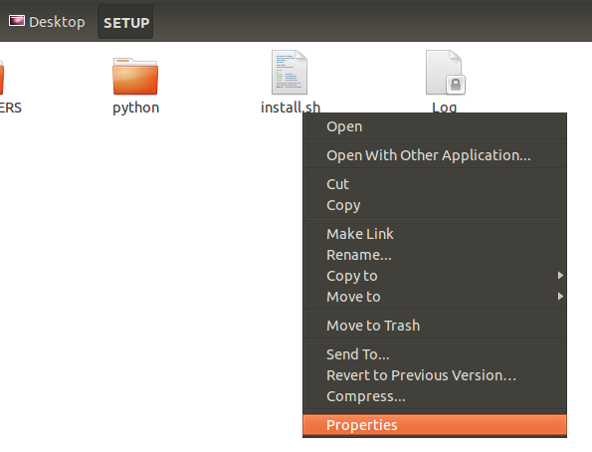
- Go to the Permissions tab and tick (ON) the option to Allow executing file as program
(See next page for screenshot)
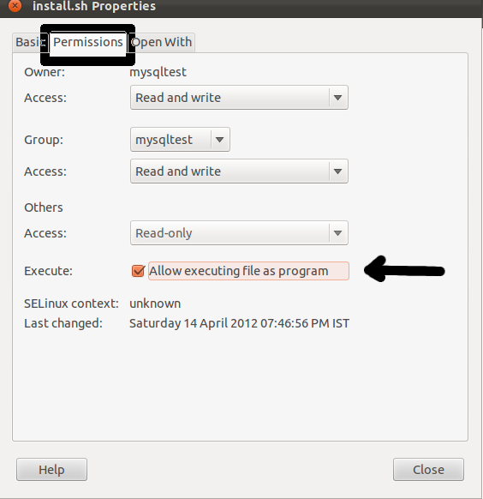

Click close button and double click install.sh
- A window like this will pop up. Press the Run button.
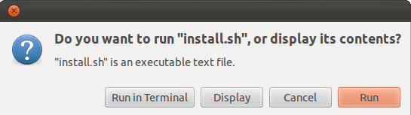
- You would be asked to enter your password. Enter the password that you use to log into your system. (Check the next page for a screen shot)
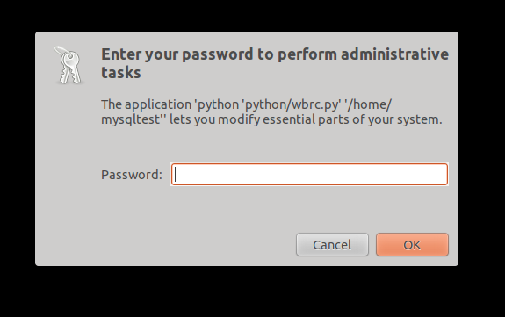
- Next, follow the on screen instructions and finish the installation till the installation wizard closes.
- The setup automatically installs Google Chrome web browser on the target system. Open Google Chrome and navigate to http://localhost/ to sign up or login. You may also double click on the graphical icon that gets generated on your Desktop to launch the project:
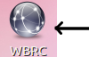
- You may use the demo by logging in with demo as userID and demo as the password.
- You may also sign up into the system and begin administering your own remote hosts.
- The SENIOR account is configured by default to view log related information. You may login using the regular login form, with username SENIOR and password demo

